Hasil Menjalankan File

Array.js

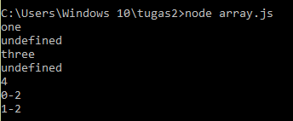

breakContinue.js

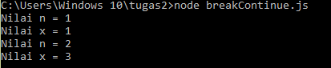

breakWithLabel.js



const.js

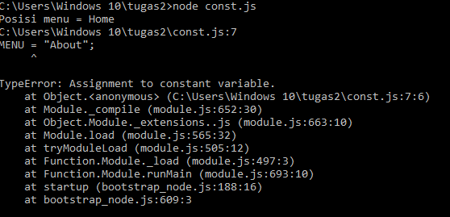

doWhile.js

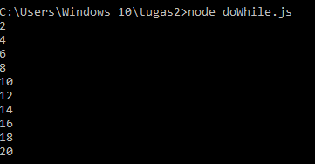

dynamic.js



for.js

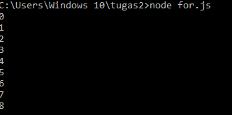

forIn.js

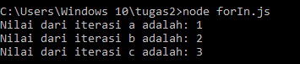

fungsiAnonim.js



fungsiRekursif.js



if.js

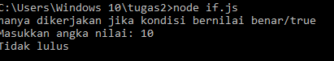

json.js



nested.js

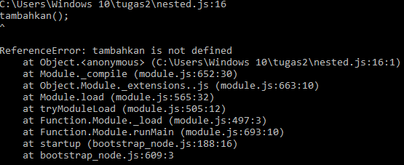

readline.js

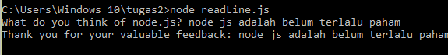

switch.js

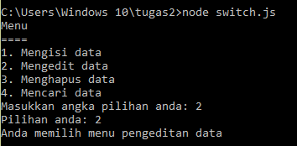

throw.js



try.js

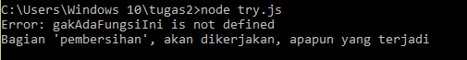

while.js

